**MODULE : 2**

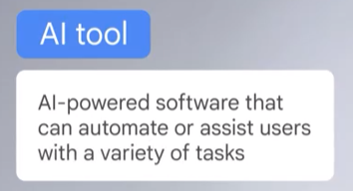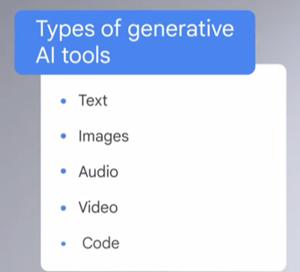  
Generative AI – AI that can generate new content, like text, images, or other media.

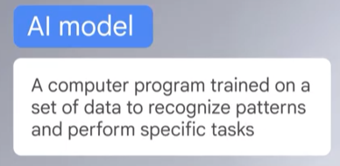

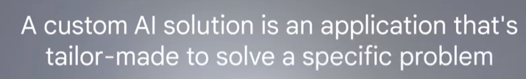  
**AI tools and AI models**

Terms like *AI tools* and *AI models* can be confusing because they sound similar but refer to different things. Recall that an **AI tool** is AI-powered software that can automate or assist users with a variety of tasks. An **AI model** is a computer program trained on sets of data to recognize patterns and perform specific tasks.

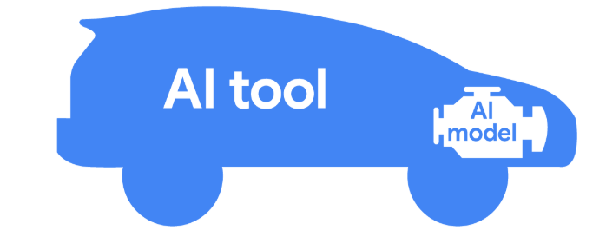  
  
  
  
  
  
  
  
**Understanding AI Tools and Model Training**

**The AI Tool vs. the AI Model**  
An AI tool is like a car—designed with a user-friendly interface (e.g., a steering wheel or dashboard) to help users reach their destination, or complete tasks. The real power lies under the hood: the AI model. This model processes user input, enabling the tool to function. Just like different vehicles serve different purposes (e.g., sedans for commuting or trucks for hauling), AI tools are built for specific tasks—such as generating text, editing images, writing code, or creating videos.

Some tools use multiple AI models working together like a "family," where each model specializes in a subtask. This enhances flexibility and expands the tool’s capabilities. These are known as **multimodal tools**, which you'll explore later in the course.

**The Process of Training an AI Model**  
AI models are built through a process called **training**. Below is a simplified example of training a model to predict rainfall:

1. **Define the problem**
   * Goal: Help commuters avoid rain.
   * Step: Consider AI capabilities and identify a suitable solution.
2. **Collect relevant data**
   * Step: Gather historical weather data over the past 50 years.
3. **Prepare the data**
   * Step: Label key features like temperature, humidity, and air pressure.
   * Tip: Split data into a **training set** (to learn from) and **validation set** (to test against).
4. **Train the model**
   * Step: Use machine learning algorithms to identify patterns (e.g., high humidity + low pressure = rain).
5. **Evaluate the model**
   * Step: Test the model using the validation set.
   * Action: Identify issues like bias or missing data and improve the model if needed.
6. **Deploy the model**
   * Step: Integrate the trained model into an AI tool that helps people plan around rain.

**Iterative Refinement**  
Model training is **iterative**. Designers repeat and refine steps until optimal performance is achieved. Even after deployment, AI tools must be monitored. New inputs from users can expose challenges, requiring further updates and feedback loops.

**Conclusion**  
Understanding how AI models are created helps you choose the right AI tool—and use it effectively—to achieve your goals.

**Prompt** – Text Input that provides instructions to the AI model on how to generate output.

**Human in the loop approach** – A combination of machine and human intelligence to train, use, verify and refine AI mdoels.

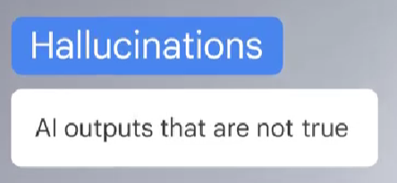**Responsible AI** – The principle of developing and using AI ethically, with the intent of benefiting people and society while avoiding harm.  
  
**Knowledge Cutoff** – The concept that an AI model is trained at a specific point in time, so it doesn’t have any knowledge of events or information after that date.

